Website Report for [www.dentoclock.in](http://www.dentoclock.in/)



The HOTH

111 2nd Ave NE, Suite 1500, St. Petersburg, FL 33701

877-720-4684

[support@thehoth.com](mailto:support@thehoth.com)

[thehoth.com](http://thehoth.com/)

This report grades your website based on the strength of various SEO factors such as On Page Optimization, O Page Links, Social and more. The overall Grade is on a A+ to F- scale, with most major, industry leading websites in the A range. Improving your grade will generally make your website perform better for users and rank better in search engines. There are recommendations for improving your website at the bottom of the report. Feel free to reach out to us if you’d like us to help with improving your website’s SEO!

Audit Results for [www.dentoclock.in](http://www.dentoclock.in/)



**D+**

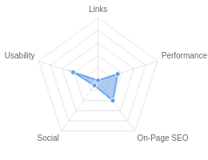**Your page could be better**

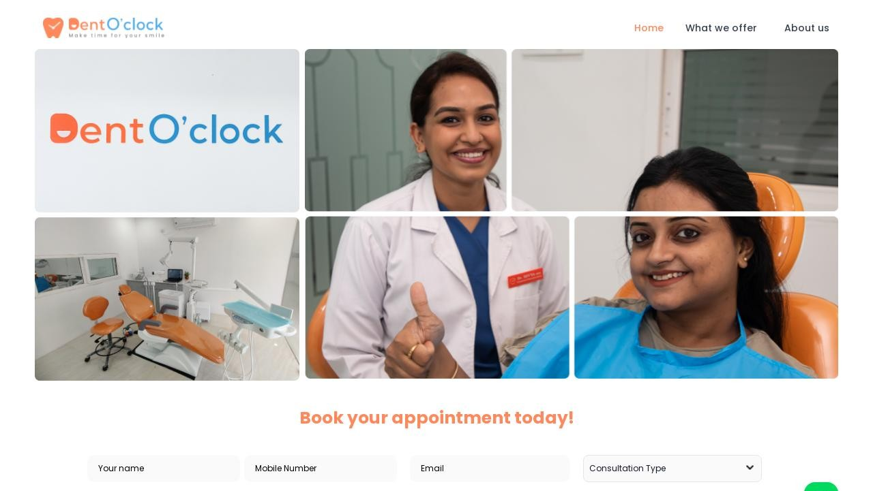

Recommendations: 22



**C-**



**F**



**C**



**D+**



**F**

On-Page SEO

Links

Usability

Performance

Social

Recommendations

# Execute a Link Building Strategy

Links

High Priority

**Include a meta description tag**

On-Page SEO

High Priority

# Implement a redirect to HTTPS on your website

On-Page SEO

Medium Priority

**Implement a XML sitemaps file**

On-Page SEO

Medium Priority

# Reduce your total page file size

Performance

Medium Priority

**Add Canonical Tag**

On-Page SEO

Medium Priority

# Add Alt attributes to all images

On-Page SEO

Low Priority

**Create and link your Facebook Page**

Social

Low Priority

# Use your main keywords across the important HTML tags

On-Page SEO

Low Priority

**Make use of HTTP/2+ protocol**

Performance

Low Priority

# Optimize your page for Mobile PageSpeed Insights

Usability

Low Priority

**Optimize your page for Desktop PageSpeed Insights**

Usability

Low Priority

# Implement an analytics tracking tool

On-Page SEO

Low Priority

**Add Schema Markup**

On-Page SEO

Low Priority

# Please add Facebook Open Graph Tags

Social

Low Priority

**Add Twitter Cards**

Social

Low Priority

# Create and link an associated YouTube channel

Social

Low Priority

**Setup & Install a Facebook Pixel**

Social

Low Priority

# Remove inline styles

Performance

Low Priority

**Add Local Business Schema**

Other

Low Priority

# Minify your CSS and JS Files

Performance

Low Priority

**Review and Increase Font Sizes across devices**

Usability

Low Priority

On-Page SEO Results

# Your On-Page SEO could be better



**C-**

Your page has some level of On-Page SEO optimization but could be improved further. On-Page SEO is important to ensure Search Engines can understand your content appropriately and help it rank for relevant keywords. You should ensure that HTML Tag Content is completed correctly and align text content to target keywords.

# Title Tag

You have a title tag of optimal length (between 10 and 70 characters). DentoClock

Length : 10

# Meta Description Tag

Your page appears to be missing a meta description tag.

A meta description is important for search engines to understand the content of your page, and is often shown as the description text blurb in search results.

# SERP Snippet Preview

This illustrates how your page may appear in Search Results. Note, this is intended as a guide and Search Engines are more frequently generating this content dynamically.

[http://www.dentoclock.in](http://www.dentoclock.in/) ⋮

DentoClock

# Hreflang Usage

Your page is not making use of Hre ang attributes.

# Language

Your page is using the lang attribute. Declared: English

# H1 Header Tag Usage

Your page has a H1 Tag.

# H2-H6 Header Tag Usage

Your page is making use multiple levels of Header Tags.

Header Tag Frequency

H2 2

H3 1

H5 3

H6 0

H4 4

# Keyword Consistency

Your page's main keywords are not distributed well across the important HTML tags.

Your page content should be focused around particular keywords you would like to rank for. Ideally these keywords should also be distributed across tags such as the title, meta and header tags.

Individual Keywords

Keyword Title Meta Description

Tag

Headings Tags Page Frequency

dental    20

dentistry    9

care    9

patient    8

mds    7

divya    7

treatments    7

dentist    6

Phrases

Phrase Title Meta Description

Tag

dr divya    7

Headings Tags Page Frequency

root canal    5

exceptional care    3

canal treatment    3

cosmetic dentistry    3

root canal treatment

painless root    2

   3

dental care    2

# Amount of Content

Your page has a good level of textual content, which will assist in it's ranking potential. Word Count: 850

# Image Alt Attributes

You have images on your page that are missing Alt attributes.

We found 46 images on your page and 46 of them are missing the attribute.

Alt attributes are an often overlooked and simple way to signal to Search Engines what an image is about, and help it rank in image search results.

# Canonical Tag

Your page is not using the Canonical Tag.

The Canonical Tag tells Search Engines the primary URL of a page. Google recommends all pages specify a Canonical.

# Noindex Tag Test

Your page is not using the Noindex Tag which prevents indexing.

# Noindex Header Test

Your page is not using the Noindex Header which prevents indexing.

# SSL Enabled

Your website has SSL enabled.

# HTTPS Redirect

Your page does not redirect to a HTTPS (SSL secure) version.

# Robots.txt

Your website appears to have a robots.txt le.

<http://www.dentoclock.in/robots.txt>

# Blocked by Robots.txt

Your page does not appear to be blocked by robots.txt.

# XML Sitemaps

We have not detected or been able to retrieve a XML sitemaps le successfully.

Sitemaps are recommended to ensure that search engines can intelligently crawl all of your pages.

# Analytics

We could not detect an analytics tool installed on your page.

Website analytics tools like Google Analytics assist you in measuring, analyzing and ultimately improving tra c to your page.

# Schema.org Structured Data

We have not detected any usage of Schema.org on your page.

Schema.org is a structured data markup for webpages which helps Search Engines understand your site better and provide rich snippets directly in their search results.

Rankings

# Top Keyword Rankings

This shows your top 10 Keyword Rankings in the speci c location. The list is ordered by the keywords that drive the most tra c to your page.

|  |  |  |  |  |
| --- | --- | --- | --- | --- |
| Keyword | Country &  Language | Position | Total  Searches | Estimated  Tra c |
| dentist clock | HI | 20 | 170 | 0 |

# Keyword Positions

This shows you a summary of the positions for your Keyword Rankings. The higher you rank, the more likely you are to capture tra c, with recent research showing that as much as 92% of clicks happen on the rst page.

Position Keywords

Position 1 0

Position 2-3 0

Position 4-10 0

Position 11-20 1

Position 21-30 0

Position 31-100 0

Links

# Backlink Summary

You have a reasonably weak level of backlink activity to this page.

Search Engines use backlinks as a strong indicator of a page's authority, relevance and ranking potential. There are various strategies available to gain links to a page to improve this factor



**0**



**0**

Domain Strength

Page Strength



**0**

Referring Domains

**0**

Backlinks

|  |  |  |  |  |  |
| --- | --- | --- | --- | --- | --- |
| **0**  Nofollow Backlinks | **0**  Dofollow Backlinks | **0**  Edu Backlinks | **0**  Gov Backlinks | **0**  Subnets | **0**  IPs |

# Top Backlinks

We haven't found any backlinks to report for this site.

# Top Pages by Backlinks

We haven't found any Top Pages data for this site.

# Top Anchors by Backlinks

We haven't found any Anchor Text data for this site.

# Top Referring Domain Geographies

We haven't found any Geographic Data for this site.

# On-Page Link Structure

We found 9 total links. 67% of your links are external links and are sending authority to other sites. 0% of your links are nofollow links, meaning authority is not being passed to those destination pages.

# Friendly Links

Your link URLs appear friendly (easily human or search engine readable).

Usability

# Your usability could be better



**C**

Your page is OK but could be more usable across devices. Usability is important to maximize your available audience and minimize user bounce rates (which can indirectly a ect your search engine rankings).

# Device Rendering

This check visually demonstrates how your page renders on di erent devices. It is important that your page is optimized for mobile and tablet experiences as today the majority of web tra c comes from these sources.

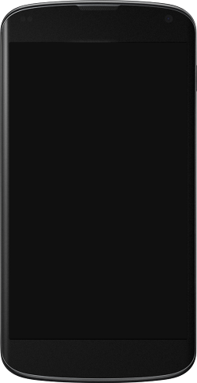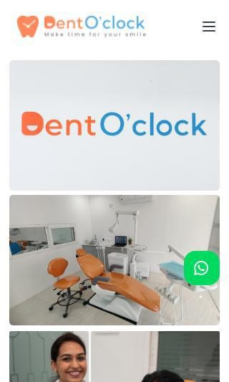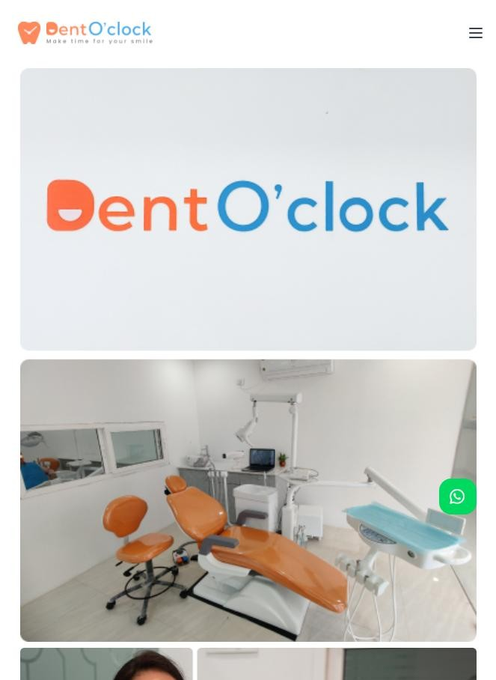

# Google's Core Web Vitals

Google is indicating that they do not have 'su cient real-world speed data for this page' in order to make a Core Web Vitals assessment. This can occur for smaller websites or those that are not crawl- able by Google.

# Use of Mobile Viewports

Your page speci es a viewport matching the device's size, allowing it to render appropriately across devices.

# Google's PageSpeed Insights - Mobile

Google is indicating that your page is scoring poorly on their Mobile PageSpeed Insights evaluation.

Note that this evaluation is being performed from US servers and the results may di er slightly from an evaluation carried out from Google's PageSpeed Web Interface as that reporting localizes to the region in which you are running the report.

Google has indicated that the performance of a webpage is becoming more important from a user and subsequently ranking perspective.



**27**

Lab Data Value

First Contentful Paint 5.9 s

Opportunities Estimated Savings

Speed Index 6.6 s

Largest Contentful Paint 81.2 s

Time to Interactive 44.2 s

Serve images in next-gen formats

Properly size images

202.47 s

Eliminate render-blocking

resources

3.22 s

170.34 s

Total Blocking Time 1.02 s

Cumulative Layout Shift 0

Reduce unused CSS 1.19 s

Reduce unused JavaScript 0.17 s

# Google's PageSpeed Insights - Desktop

Google is indicating that your page is scoring poorly on their Desktop PageSpeed Insights evaluation.

Google has indicated that the performance of a webpage is becoming more important from a user and subsequently ranking perspective.



**67**

Lab Data Value

First Contentful Paint 1.4 s

Opportunities Estimated Savings

Speed Index 1.9 s

Largest Contentful Paint 13.3 s

Time to Interactive 1.6 s

Serve images in next-gen formats

Properly size images

33.28 s

Eliminate render-blocking

resources

0.58 s

26.97 s

Total Blocking Time 0.08 s

Cumulative Layout Shift 0.001

# Flash Used?

No Flash content has been identi ed on your page.

# iFrames Used?

There are no iFrames detected on your page.

# Favicon

Your page has speci ed a favicon.

# Email Privacy

No email addresses have been found in plain text on your page.

# Legible Font Sizes

There is some text on your page that is small and may not be legible enough for particular users.

We recommend reviewing all text on your page in di erent devices to ensure that it is of appropriate size.

# Tap Target Sizing

The links and buttons on your page appear to be appropriately sized for a user to easily tap on a touchscreen.

Performance Results

# Your performance could be better



**D+**

Your page's performance has some issues and room for improvement. Performance is important to ensure a good user experience, and reduced bounce rates (which can also indirectly a ect your search engine rankings). We recommend addressing the highlighted factors below.

# Page Speed Info

Your page loads in a reasonable amount of time.

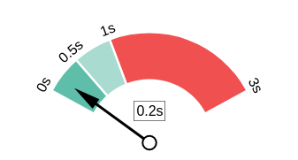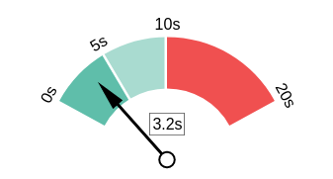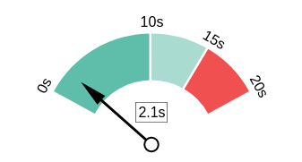Server Response All Page Content Loaded All Page Scripts Complete

# Download Page Size

Your page's le size is quite large which, regardless of other optimizations, can reduce load speed and impact user experience.

A general rule is to keep your page under 5MB in total le size.

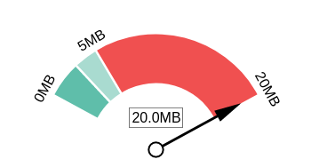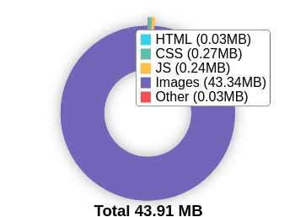Download Page Size Download Page Size Breakdown

# Website Compression (Gzip, Deflate, Brotli)

Your website appears to be using a reasonable level of compression.

Compression Rates Raw Page Size Breakdown

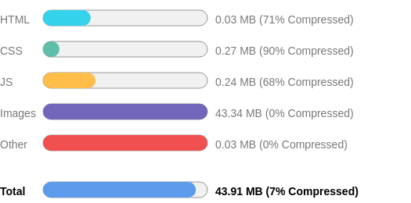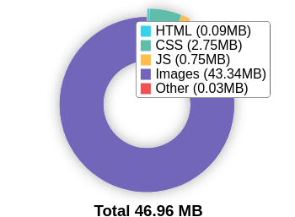

# Number of Resources

This check displays the total number of les that need to be retrieved from web servers to load your page.



59

Total Objects

1

Number of HTML Pages

6

Number of JS Resources

6

Number of CSS Resources

39

Number of Images

7

Other Resources

# Google Accelerated Mobile Pages (AMP)

This page does not appear to have AMP Enabled.

# JavaScript Errors

Your page is not reporting any JavaScript errors.

# HTTP2 Usage

Your website is using an outdated HTTP protocol.

We recommend enabling HTTP/2+ or protocol for your website as it can signi cantly improve page load speed for users.

# Optimize Images

All of the images on your page appear to be optimized.

# Minification

Some of your JavaScript or CSS les do not appear to be mini ed.

Mini cation is a reasonably simple way to reduce page size, and subsequently load time.

# Deprecated HTML

No deprecated HTML tags have been found within your page.

# Inline Styles

Your page appears to be using inline styles.

Inline styles are an older coding practice and discouraged in favor of using CSS style sheets, due to their ability to degrade page load performance and unnecessarily complicate HTML Code.

Social Results

# Your social needs improvement



**F**

You appear to have a weak social presence or level of social activity (or we may just not be able to see your pro les!). Social activity is important for customer communication, brand awareness and as a marketing channel to bring visitors to your website. We recommend that you list all of your pro les on your page for visibility, and begin to build a following on those networks.

# Facebook Connected

No associated Facebook Page found as a link on your page.

# Facebook Open Graph Tags

We have not found Facebook Open Graph Tags on your page.

Facebook Open Graph Tags are a type of structured data that can be placed on your page to control what content is shown when a page is shared on Facebook.

# Facebook Pixel

We have not detected a Facebook Pixel on your page.

Facebook's Pixel is a useful piece of analytics code that allows you to retarget visitors if you decide to run Facebook Ads in future.

# Twitter Connected

Your page has a link to a Twitter pro le.

# Twitter Cards

We have not detected Twitter Cards on your page.

Twitter Cards are a type of structured data that can be placed on your page to control what content is shown when a page is shared on Twitter.

# Instagram Connected

Your page has a link to an Instagram pro le.

# LinkedIn Connected

Your page has a link to a LinkedIn pro le.

# YouTube Connected

No associated YouTube channel found linked on your page.

# YouTube Activity

No associated YouTube channel found linked on your page.

Local SEO

# Local Business Schema

No Local Business Schema identi ed on the page.

# Google Business Profile Identified

A Google Business Pro le was identi ed that links to this website.



DentO’clock Dental Care

# Google Business Profile Completeness

The important business details are present on the Google Business Pro le.

Address Metro pillar no.1721, MM heights, 3rd

oor, plot 6, Hitech City Rd, Madhapur, Hyderabad, Telangana 500081

Phone +91 76709 80925

Site <http://www.dentoclock.in/>

# Google Reviews

The Google Business Pro le has a good rating and review count.

4.9

★★★★★

113 reviews

Rating

5

4

3

2

1

Technology Results

# Technology List

These software or coding libraries have been identi ed on your page.

Technology Version



Apache HTTP Server

 Endurance Page Cache



Google Hosted Libraries

 jQuery



jQuery CDN

 OWL Carousel



Tailwind CSS

Unpkg

# Server IP Address

162.214.81.25

# DNS Servers

ns2.bluehost.in ns1.bluehost.in

# Web Server

Apache

# Charset

text/html; charset=UTF-8